 | 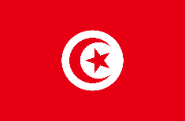 |  |  | 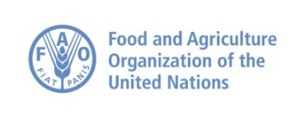

22nd JPC/REMESA 2021
Co-chair: Tunisia-Spain
Videoconference Thursday June 17 2021
(10.00 – 15.00 CET; UTC+2)

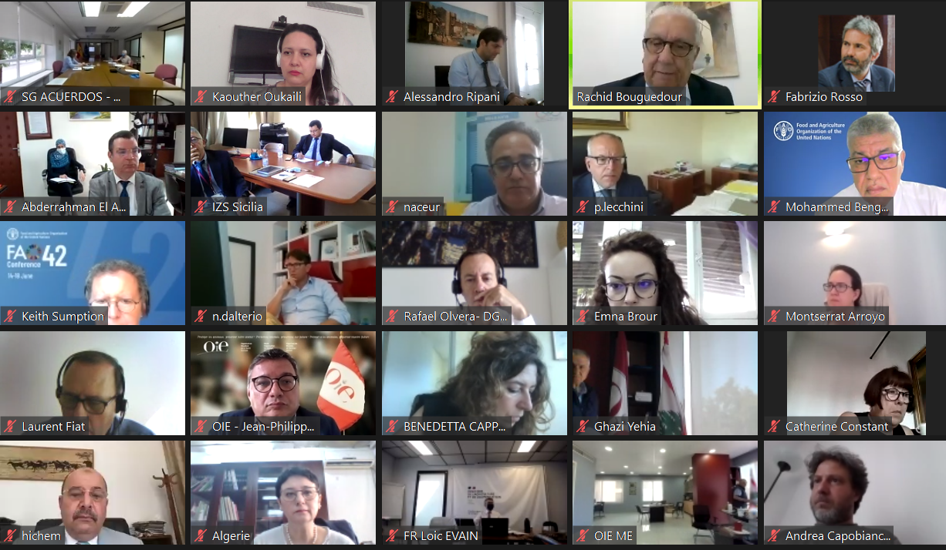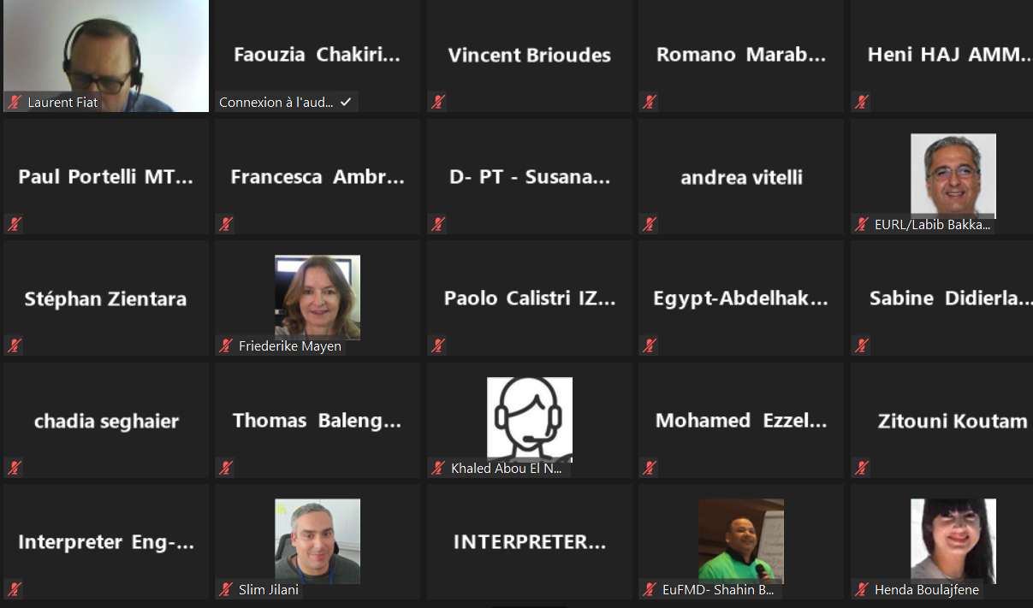

Report of the meeting

FAO/OIE Secretariat of REMESA
July 2021

Introduction
The 22nd Joint Permanent Committee meeting of the Mediterranean Animal Health Network (REMESA) was organized virtually on 17 June 2021. Sixty-five participants including the Chief Veterinary Officers of REMESA member countries or their representatives from Algeria, Egypt, France, Greece, Italy, Lebanon, Libya, Malta, Mauritania, Morocco, Portugal, Spain and Tunisia, attended the meeting. The representatives of the European Commission (DG SANTE) and the Arab Maghreb Union (UMA) also participated in the meeting. Additional institutions/organizations were invited to participate in the meeting for providing specific inputs such as EuFMD.
The meeting was the opportunity to discuss, update and inform REMESA member countries on the activities and initiatives being conducted as well as on the main epidemiological events occurred in the past six months. The governance of REMESA and – especially - the implementation of the new REMESA scientific and technical office in Palermo

Opening session
The meeting was officially opened by Dr Hichem Bouzghaia (Chief Veterinary Officer of Tunisia), Dr Almansa Valentín de Lara (Chief Veterinary Officer of Spain), Dr Jean Philippe DOP (Deputy Director General, OIE) and Dr Keith Sumption (CVO, FAO) who welcomed all the participants.
During the opening session, the importance of the network for the livestock sector was reaffirmed especially in terms of collaboration in the surveillance and prevention of priority diseases for the Mediterranean region – including vector-borne diseases - which have an impact not only on animal and public health but also on countries economy and food security.

Session 1
The session was initiated by an update provided by the OIE Sub-Regional Representation for North Africa on epidemiological situation for priority diseases in the region reviewing the immediate notifications submitted by REMESA members through WAHIS. A particular focus was also given to HPAI outbreaks and MERS-CoV by highlighting two recent scientific publications on “the Prevalence of Middle East Respiratory Syndrome Coronavirus in Dromedary Camels in Tunisia” and one on the genotypic and phenotypic characterization of MERS-CoV in Africa.
Representatives of countries provided an update on their epidemiological situation – mainly on HPAI, FMD and Rabies – related to the recent outbreaks and serotypes incursions as well as control measures.
Algeria presented the new project of animal identification and the national program for rabies control as well as the implementation of general vaccination campaigns against rabies thanks to the OIE donation of vaccines. The country is applying a vaccination campaign against PPR since 2018.
Morocco also updated the audience about animal health epidemiological situation and confirmed that Morocco is FMD free since 2019 and the control program is approved by OIE. Two cattle vaccination campaigns against FMD were organized yearly in addition to small ruminants’ vaccination campaigns in areas at risk. For HPAI, no outbreak was recorded, recalling that Morocco has implemented passive surveillance in poultry farms and active surveillance in wild birds at wet sites. Morocco also recalled that the country is committed to the global strategy to fight against rabies and that in 2021 has boosted vaccination of dogs by associating the mandated private veterinarians.
Morocco has also introduced new techniques for the management of the dog population based essentially on capture, sterilization and vaccination.
Egypt mentioned that in 2021, four sporadic cases for FMD and one case of PPR were registered while no case of Rift Valley Fever was notified. Egyptian authorities apply a national mass vaccination for FMD. In collaboration with EUFMD a national workshop on FMD risk mapping and animal mobility was organized. Mass vaccination for Lumpy Skin Disease is applied and more than 2 million of animals were vaccinated. Three compartments were declared HPAI free. During the latest OIE session, two laboratories: for HPAI and Brucellosis were recognized as references laboratories by OIE.
France stated that health situation was marked by several outbreaks of HPAI with particular severity in the Southwest area where there are ducks and goose farms.
Several outbreaks have been recorded in this zone, (96% of the total outbreaks recorded in France) and more than 3 million poultry have been stamped out as a preventive measure. The last outbreak was recorded in April 2021 and therefore the risk is evaluated as negligible since May 28, 2021.
Greece mentioned that since February 2017, no outbreaks of HPAI were registered until April 2021 when outbreaks of HPAI was reported in wild birds.
In Italy, two outbreaks of HPAI were notified, the latest in April 2021.
Lebanon reported that a FMD surveillance program was implemented in collaboration with EUFMD and a risk based strategic plan for FMD control will be elaborated. For LSD, 4000 doses were delivered to Lebanon with the support of FAO and 6% of cattle were vaccinated along the borders.
The sanitary situation is stable in Malta and major animal diseases are absent (tuberculosis, brucellosis, rabies…). A surveillance program of ASF is in place and also a surveillance program for HPAI is in progress.
Portugal registered cases of brucellosis in small ruminants and along with tuberculosis still remain a problem in Portugal.
Spain is free from tuberculosis and brucellosis.
Tunisia has reported significant outbreaks of Bluetongue at the end of 2020 with no availability of vaccine adapted to the circulating strain. An awareness and sensitization program for breeders has been set up to control vectors. Sporadic cases of equine influenza have also been recorded and controlled. Annual vaccination campaigns are applied for rabies, FMD, sheep pox and brucellosis.
At the end of the first session, ANSES presented the reagents banks for FMD diagnosis and highlighted the importance of having this bank for rapid response in an emergency situation. Fast, reliable and accurate laboratory results are needed to implement appropriate and timely measures and the immediate availability of validated kits in sufficient quantities is a major challenge in the control of FMD. Dr Zientara concluded that the implementation of reagents banks for FMD diagnostic should help for the rapid response to FMD crisis. A debate was held concerning funding of this bank and its operational mechanisms.

Session 2
The second session of the meeting was launched by a presentation on the REMESA activities during the last semester of 2021. FAO Sub Regional Representation for North Africa (FAO-SNE) presented the state of play activities related to HPAI, poultry sector study, world bee day, bioterrorism and agro-crime. OIE Sub-Regional Office for North Africa (OIE-NA) presented the OIE emergency management exchange pilot project between Tunisia and Italy within the framework of the agro-crime project (consortium OIE-FAO-INTERPOL) and gave an overview of the outcomes of the regional workshop on the rabies surveillance vaccination in dogs held on 16-17 February 2021. OIE-NA also presented the OIE twinning project on animal welfare between Italy and Tunisia.
Dr F. Rosso (FAO) presented the EUFMD risk reduction programme to support REMESA countries. This program is based on enhancing coordination, improving early warning for FAST diseases and capacity development for surveillance and control programmes. He also gave an overview on the main events organized in the region such as promotion of Public Private Partnership (PPP) to assist surveillance /control of FAST, establishment of the Group for Vaccination Advice (GVA), improvement of the national capacity in risk assessment and mapping, design risk-based surveillance and control plans for FAST diseases and laboratories diagnosis capacity for FAST. He also presented the EUFMD priorities and work plan for 2021-2023.
Dr Andrea Vitelli from the IZSAM of TERAMO underlined the importance of digitization for public administration and presented the Italian Vet-Info system as an example followed by the project for establishing an information system of the Tunisian veterinary services supported by FAO in Tunisia.
Dr Madhur Dhingra made a presentation of the FAO EMA-i Event Mobile Application, a real time reporting system developed by FAO in 2012 to support animal health diseases reporting, early warning and surveillance.
During discussions, France confirmed the importance of information systems for data exchange and for creating the link between public veterinary services and private veterinary sector as well as for trade between countries of the region. Especially the crucial importance of the virtual health certificate with electronic signature or even the complete digitization of the whole procedure. This proposal was supported by Tunisia. Morocco has developed a sanitary and phytosanitary information system and another system for the digitization of animal identification and an e-health project that will start in 2022.
Dr Paolo Calistri, IZS AM of Teramo, gave a brief overview of the institute's activities related to covid-19 including the Whole Genomic Sequencing (WGS). Italian veterinary services are under the umbrella of the Ministry of Health, which facilitates intersectoral collaboration and the application of one-health policies. Dr Calistri highlighted that the integrated one-health activities were able to enhance rapid diagnostics and to contribute to a better knowledge on the dynamic and risk factors of SARS-CoV-2 infection.
Dr Kaouther Oukaili from FAO-NA presented the project “strengthening resilience face to agro-terrorism and agro-crime affecting the animal health” which is a 3-years project implemented by the consortium FAO-OIE-INTERPOL and funded by the Global Affairs of Canada. This project aims to strengthen the capacities of countries against bioterrorism and agro-crime. She also gave an overview on the AMR-MPTF-Morocco project “Support for the implementation of the National Action Plan to fight Antimicrobial resistance through a One Health approach in Morocco”. This project is implemented by the tripartite FAO-OIE-WHO- in collaboration with the three concerned ministries in Morocco: agriculture, health and environment. It aims to accelerate the implementation of the Global Action Plan on Antimicrobial Resistance mainly through policy advice, technical assistance and capacity building.
Due to the time constraints, the CVO of France, Dr Loic Evain proposed to post pone the presentation of CGAAR to the next JPC REMESA.
Dr Vincent Brioudes and Dr Naceur Baccar presented the outcomes of the survey on need for training carried out by ENSV-FVI and CNVZ as an OIE collaborating center for the training. Only seven countries filled the questionnaire. The survey will be still open until the end of June.
The working mechanisms of REMESA Scientific and Technical Unit in Palermo were presented by the CVO of Italy, Dr Pierdavide Lecchini. A proposal for structuring and governance of the scientific and technical office (STOR) of REMESA was presented. A scientific and technical committee (STC) will be established with members appointed by member countries in coordination with the secretariat for a period of three years. This technical committee should represent a link between the STOR and the secretariat. The STOR functions under the coordination of REMESA secretariat. Next steps of the STOR, which will be the official presentation of the STOR initiatives and website to all stakeholders and the organization of virtual meeting with the support of REMESA secretariat to start the dialogue with all stakeholders and share needs and priorities. He also presented the main actors and the objectives of the STOR. A kick off meeting of the STC is planned on September 2021and the proposal of activities lines will be on October of the same year.
France underlined the importance of this project and its usefulness for REMESA and asked to have all the documents presented and to examine them carefully in order to be able to choose the ideal profile for each member of the scientific committee. Dr Bouguedour suggested sending all documents on STOR and STC to the member countries for comments and suggestion. He also explained that all the proposals will come from member countries to the secretariat that will coordinate with Palermo and the ideal situation would be that the countries designate a member in the scientific committee. Dr Bengoumi confirmed that the committee relies directly to the Secretariat and he suggested sharing the terms of reference with the director and members of the scientific committee. Dr Lecchini added that he will send all the documents for suggestions and proposals.
Finally, the secretariat and Spain delegate discussed the next meeting and offered to organize it face-to-face in Spain with only CVOs if the sanitary conditions allow it while the others through remote connection. At the end the participants congratulated Dr Loic Evan who will leave the French Veterinary Services and wished good luck to his successor.

